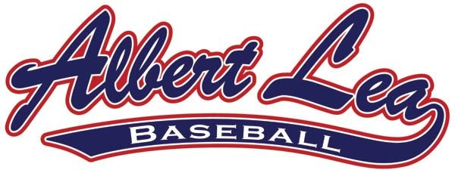
Baseball Classic Tournament
2020


Friday June 12 – Sunday June 14
Entry Fee: $400 (Make checks payable to Albert Lea Youth Baseball)
3 Game Guarantee Baseballs: 1 per Game
USA Bat Rules: If your division is a MBT Qualifier, you will be required to follow the USA bat requirements
Inclement Weather: Please see our policy under Tournaments at www.albertleabaseball.com
No Refunds will be made after confirmation has been sent unless we receive another paid registration.
League Association: Metro Baseball League___ Gopher State___ Other___ Waiver required if you do not have a AAA team or do not play in one of the leagues listed.
Please mail this completed registration form with entry fee to:
ALYBA
313 Garden Road
Albert Lea, MN 56007

Registration Form

Team Name:

City:

Age Group: (Circle one) 9AA 10A 10AA 11A 11AA

Coach/Manager:

Cell Phone: ________________Email:

Contact:

Rich Yost – President | Troy Irvine – Tournament Director
507-402-2165 | 507-381-1731
richyost16@gmail.com | alyouthbaseballboard@gmail.com
Presented by the Albert Lea Youth Baseball Association

